Step by Step Guide for AP Payment Information

On the Lawson Finance Tab
- Go to “Forms Access – Review”
  - Select “Invoice – Search by Vendor, Invoice AP90.1”
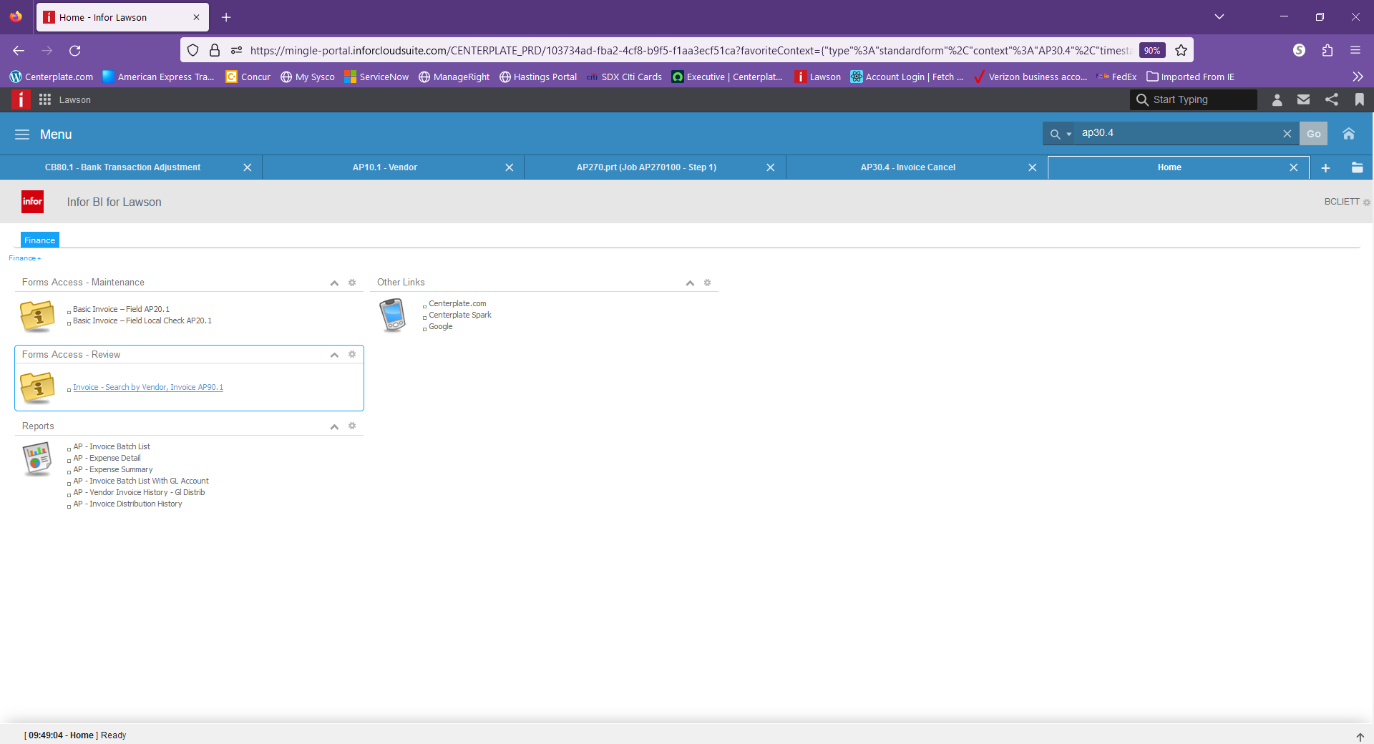
Within AP90.1
- Under Company, enter/choose “100” for US locations, “350” for Canada locations or “600” for BSO Locations
- Process level – Leave blank
- Vendor- You can enter the vendor number if you know it or use the search to find the vendor (just as you would using the AP invoice entry module (AP20).
- Vendor List – Leave blank
- Positing To- If you know the invoice number or a portion of it, you may enter it here. Do NOT hit the “ENTER” key. After you enter something in this field, hit the “INQUIRE” button at the top to do a search for this invoice record.
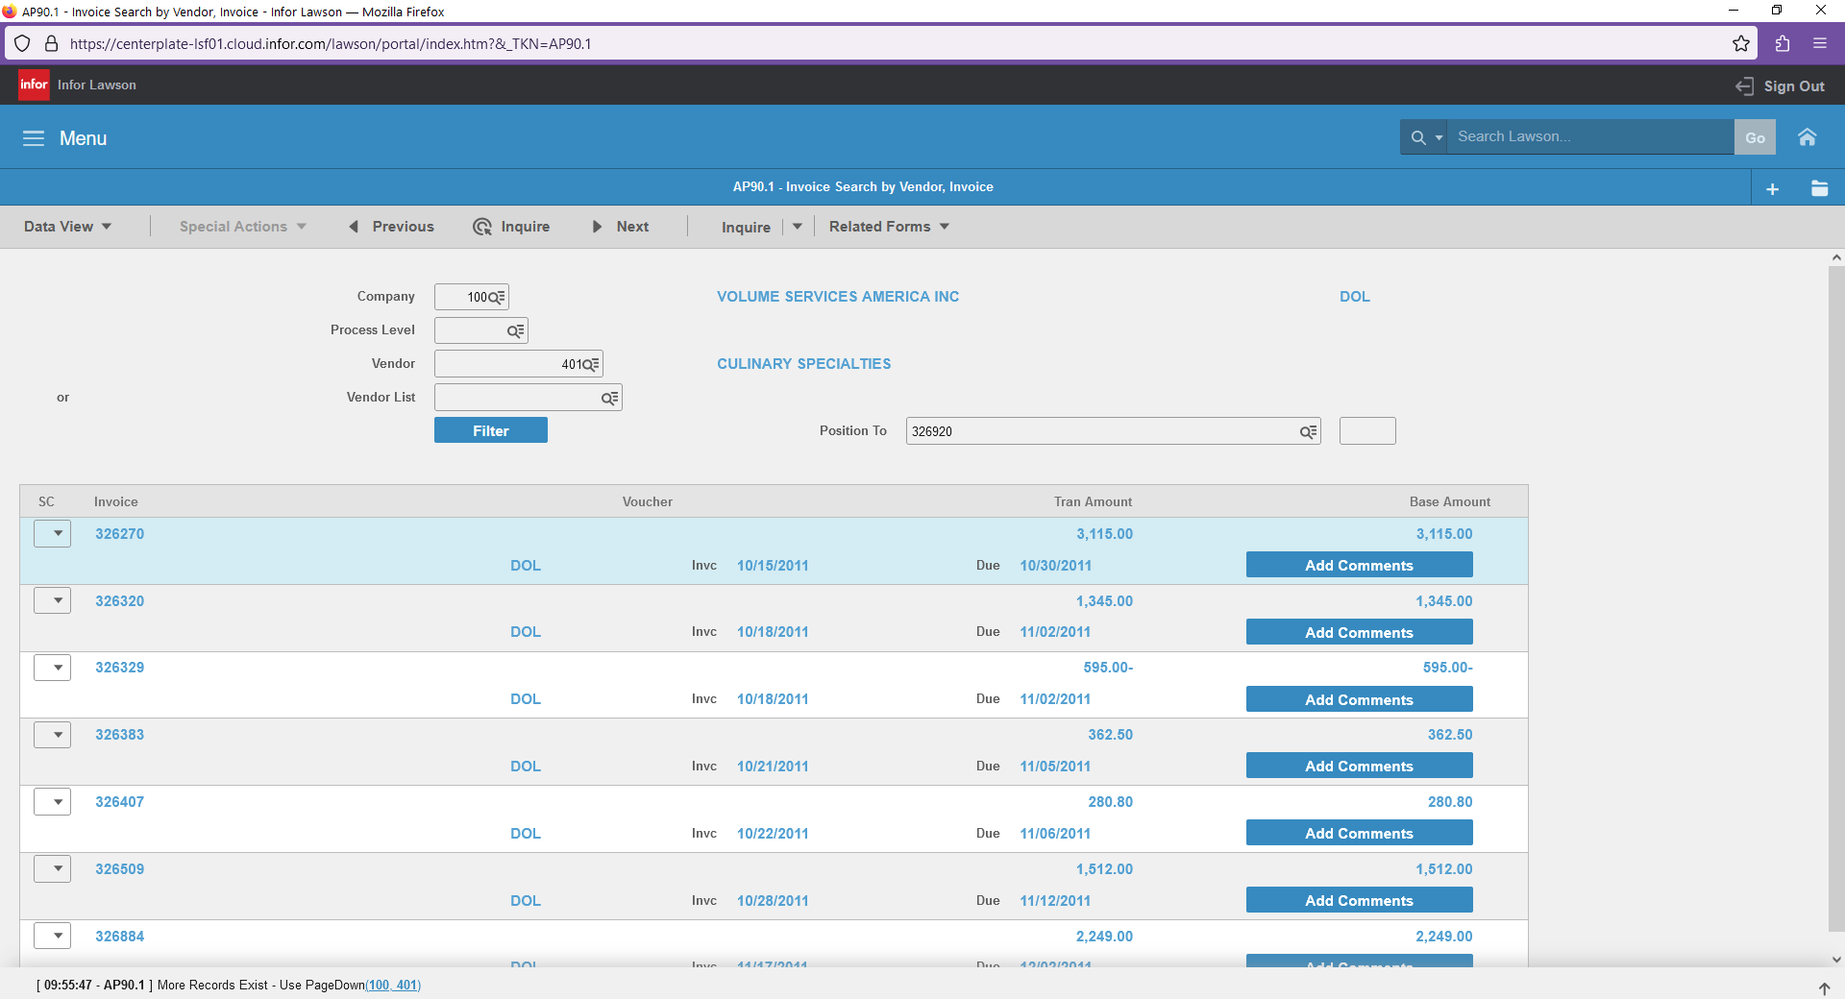

If you leave the “Position to” field blank, it will pull up all records for that vendor.

You can also use the “FILTER” button to search by:
  - Invoice date range or
  - Due date range or
  - Invoice amount range
Make sure you first change “ENABLE FILTER” to “Y” before trying to use this filter.
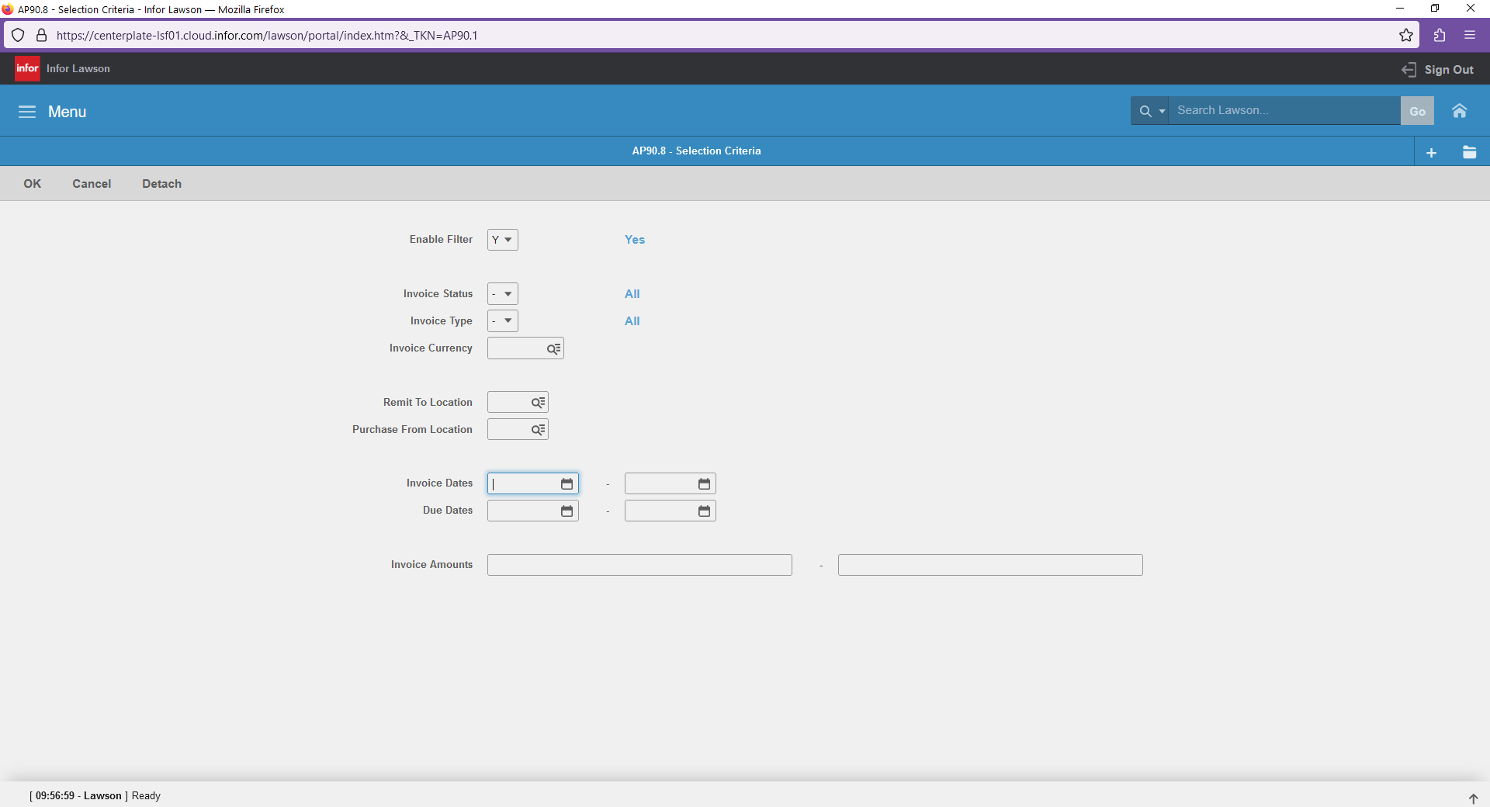
Once you have entered your filter criteria, hit the “OK” button at the top.
Once you have found the invoice

- Once you have located the invoice you are needing payment on, in the “SC” column (far left) you must RIGHT CLICK and Choose the “DRILL AROUND” pop up. You CANNOT use the dropdown arrow.
- 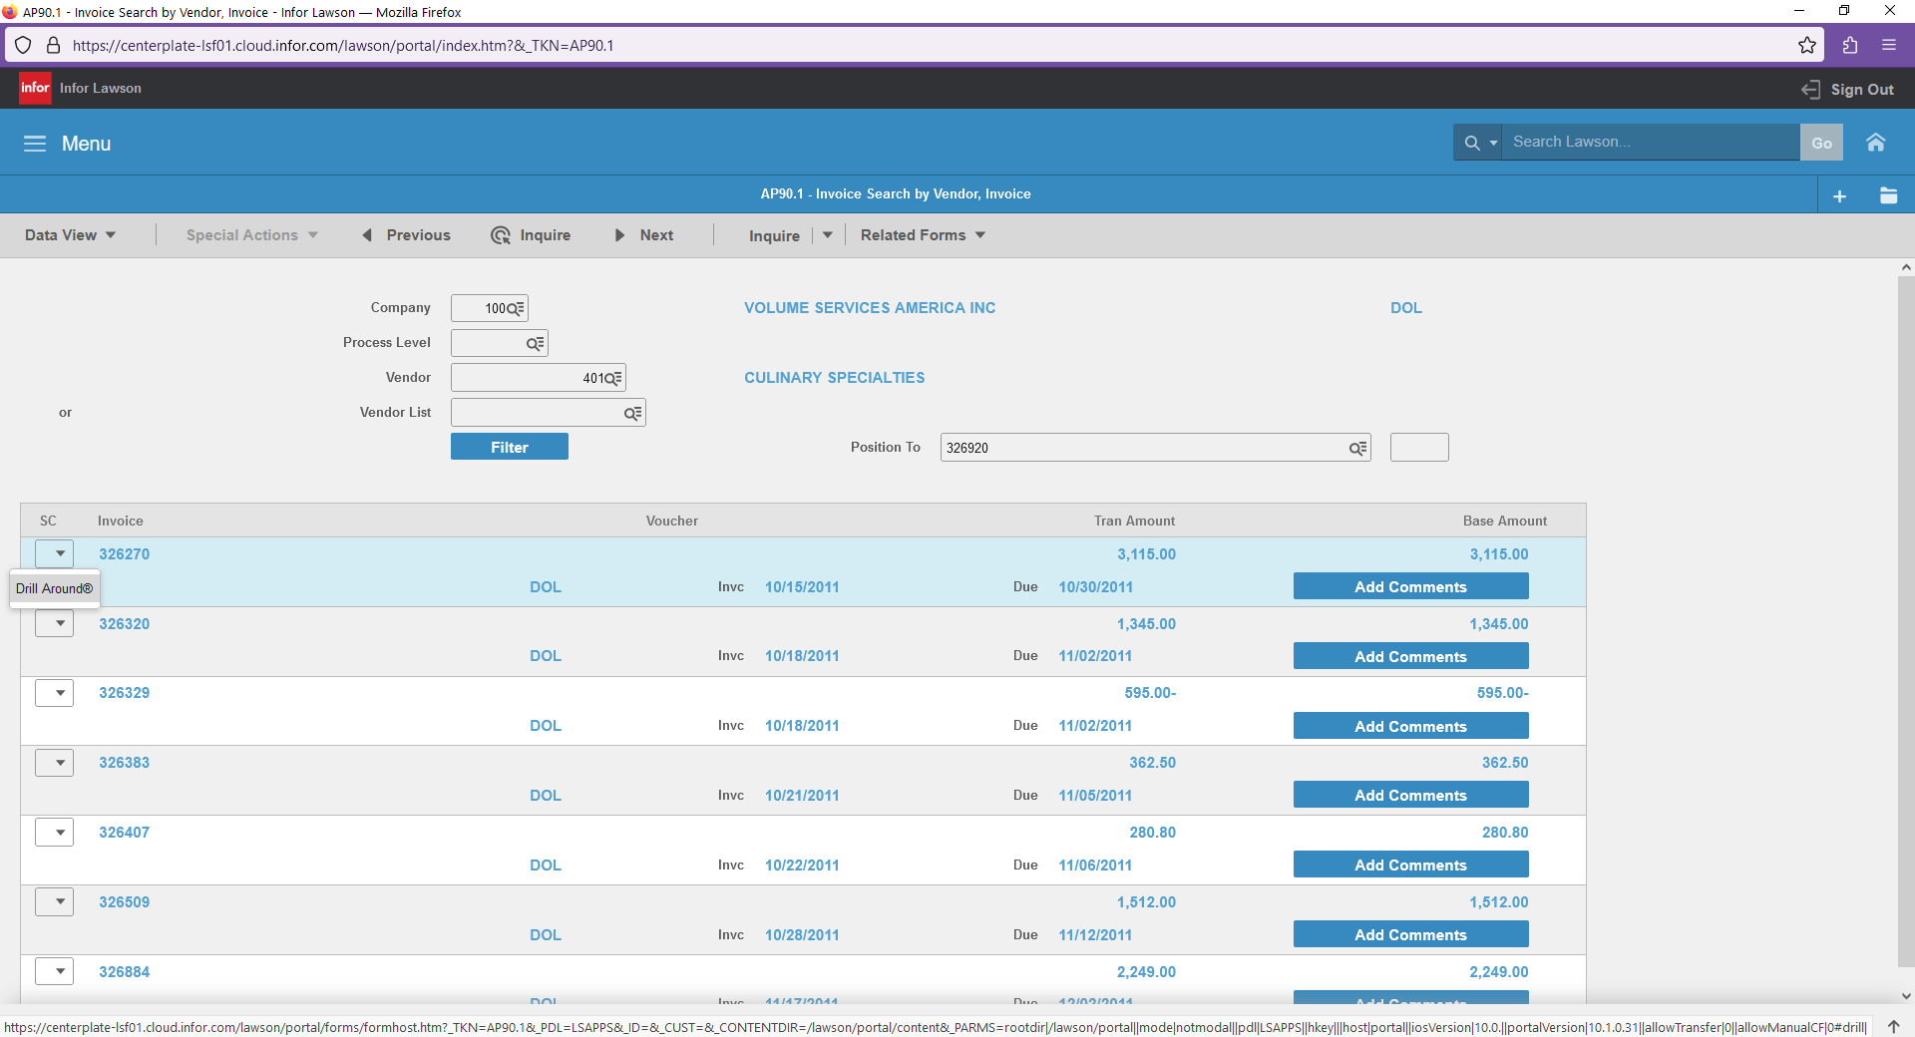
- Once in the drill around screen, this will show you the following
  - Vendor Name
  - Invoice number
  - Invoice amount
  - Payment number
  - Payment Type – “SYS” means system check (actual paper check) , “CRD” is ACH/Direct Deposit
  - Payment status “Reconcile” means cashed, “Issued” means issued by NOT cashed.
  - Invoice Date
  - Payment Date
  - Due Date
  - Vendor payment terms
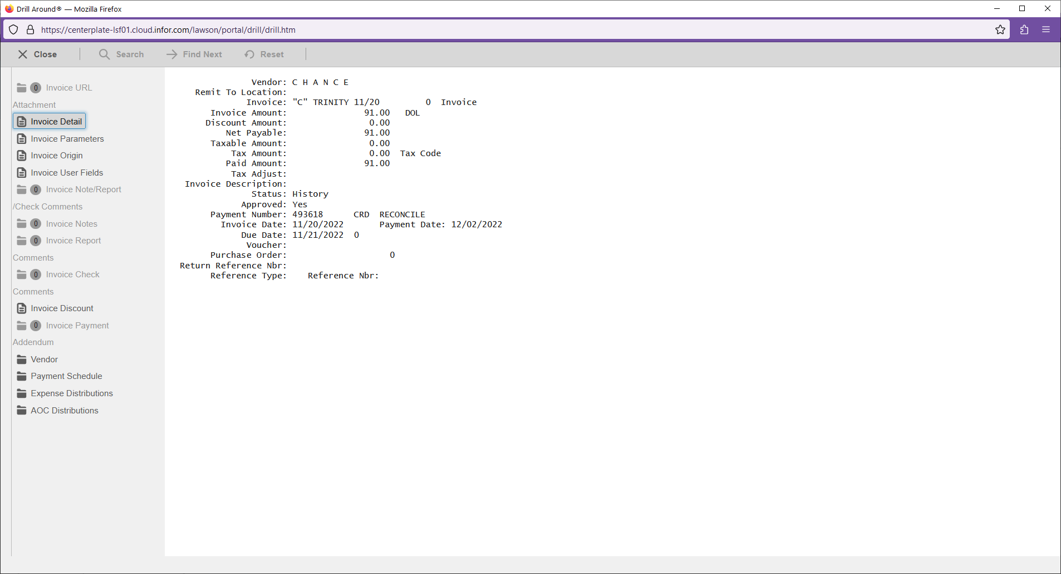

On the left (grey) area:
Invoice Origin - This will show you the AP batch and date this invoice was entered on.
Vendor – This will show you Vendor name, vendor address, vendor defaults (net terms, payment type, etc).
Expense Distributions – This where show you where this invoice was coded (unit and GL coding).
